Simulation model
We used an explicit age-structured model with the standard catch equation as the operational population dynamics model. Numbers at age and catch at age in year t (C_{a,t}) were modeled as
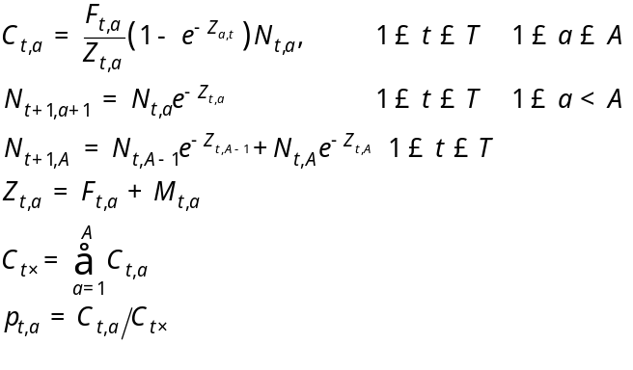
where
T is the number of years,
A is the number of age classes in the population,
N_{t,a} is the number of fish age a in year t,
C_{t,a} is the catch of age class a in year t,
p_{t,a} is the proportion of the total catch in year t, that is in age class a,
C_{t⋅} is the total catch in year t,
w_{a} is the mean body weight (kg) of fish in age class a,
F_{t,a} is the instantaneous fishing mortality for age class a, in year t,
M_{t,a} is the instantaneous natural mortality in year t for age class a, and
Z _{ta} is the instantaneous total mortality for age class a, in year t.
We reduced the freedom of the parameters listed above by restricting the variation in the fishing mortality rates (F_{t,a}) by assuming that
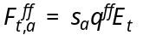

wher
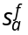 is the selectivity for age class a for fleet f,
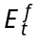 is the effort of fleet f at time t, and
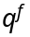 is the catchability coefficient for fleet f.
One of the control variables evaluated for the simulations was the variance of transient effort estimates (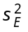).
Mean length at age was allowed to vary by year:
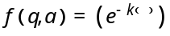
Model configurations:
Scenario | Description | 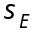 | Effort Multiplier
1 | Reference case | 0.10 | 1.0
2 | High Effort variability | 0.20 | 1.0
3 | Low effort variability | 0.01 | 1.0
4 | Low effort | 0.10 | 0.5
5 | High effort | 0.10 | 2.0
6 | Low recruitment variability | 0.10 | 1.0
7 | High recruitment variability | 0.10 | 1.0
8 | Low variability in growth at age | 0.10 | 1.0
9 | Low recent recruitment | 0.10 | 1.0
10 | Trend in fishery catchability | 0.10 | 1.0
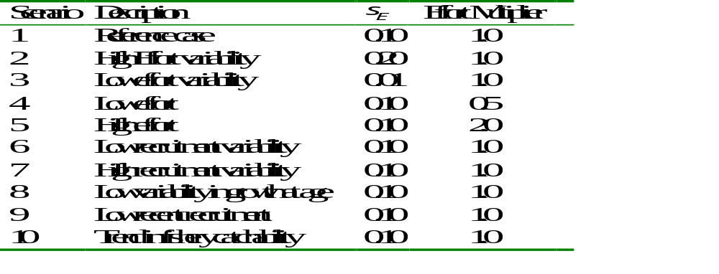

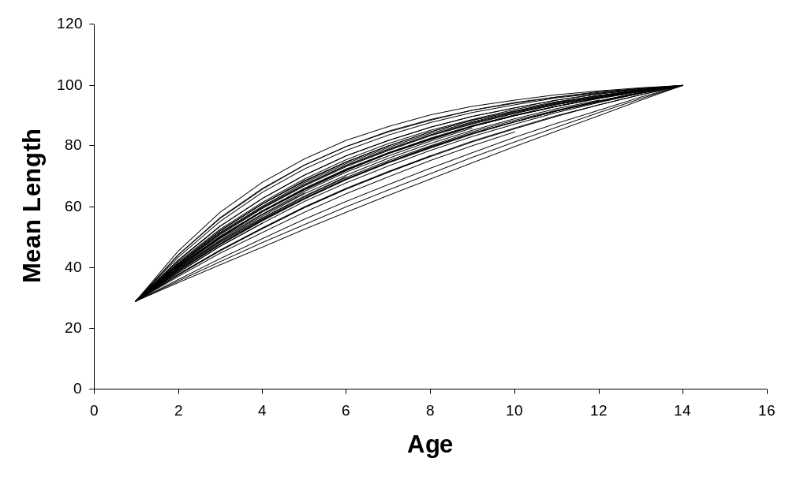

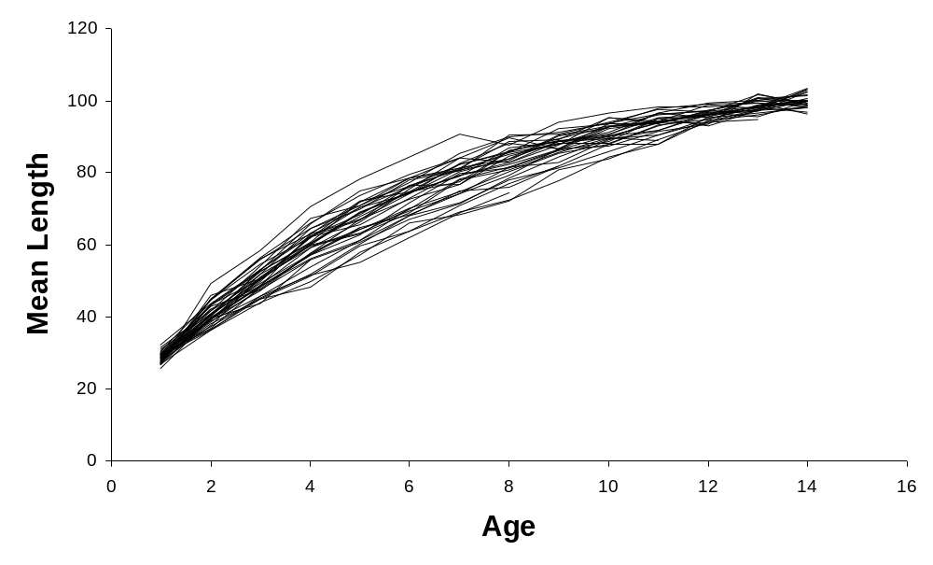
Figure 1.

Model 1

Green line = “Truth”
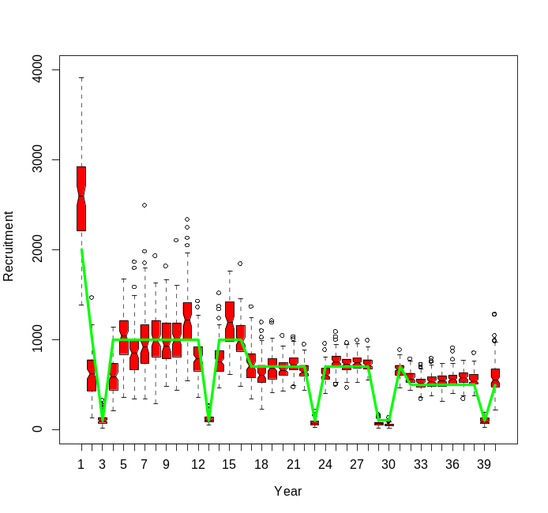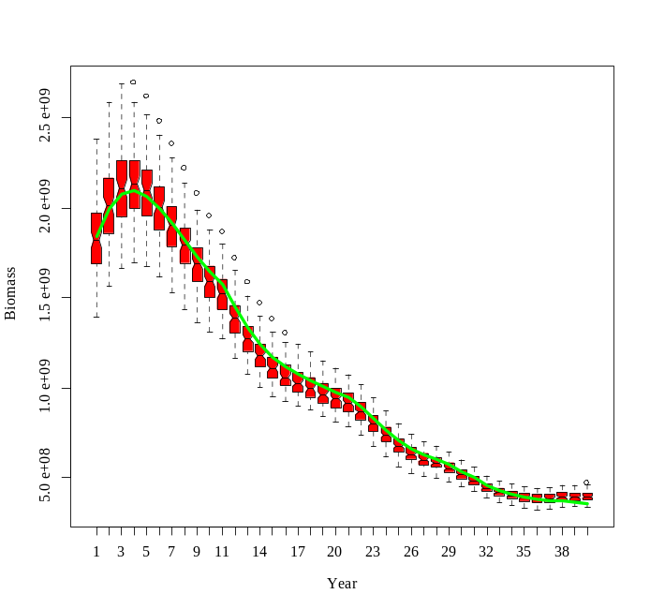

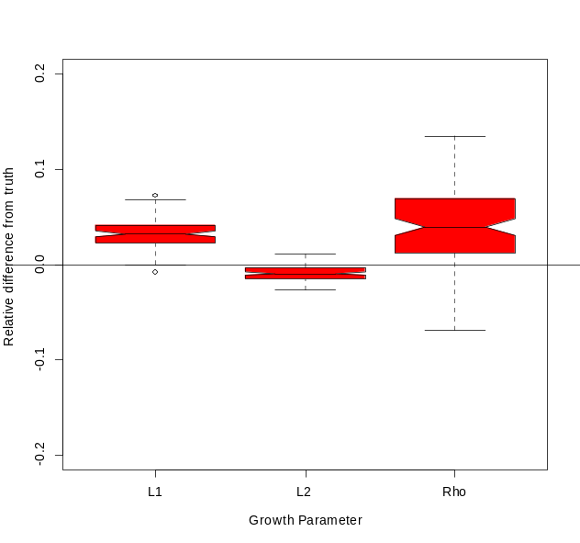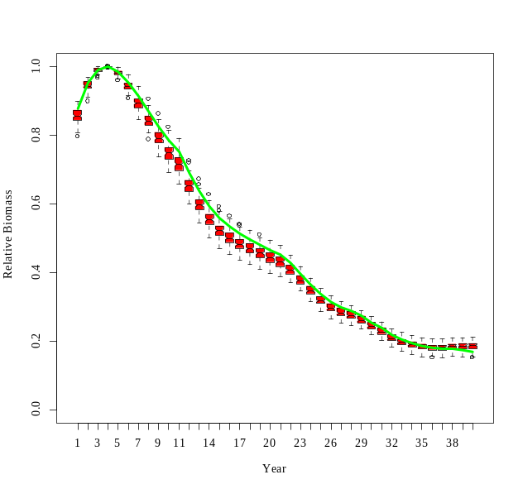

Model 2
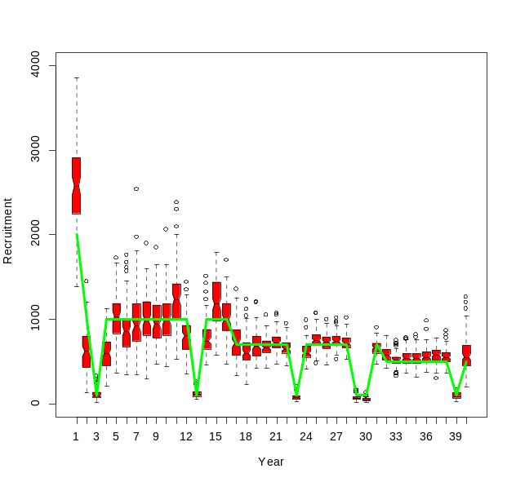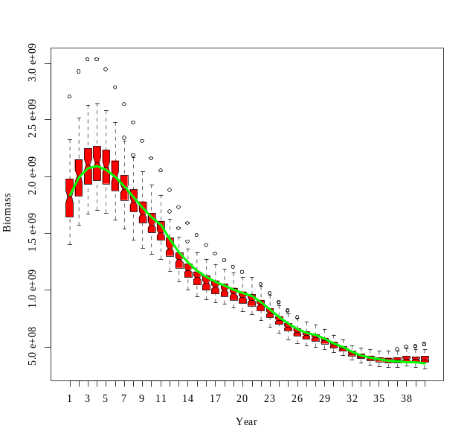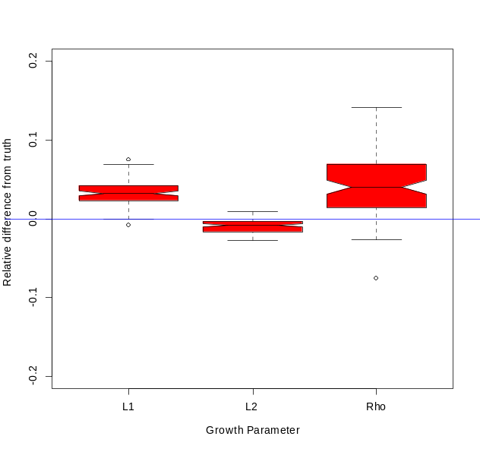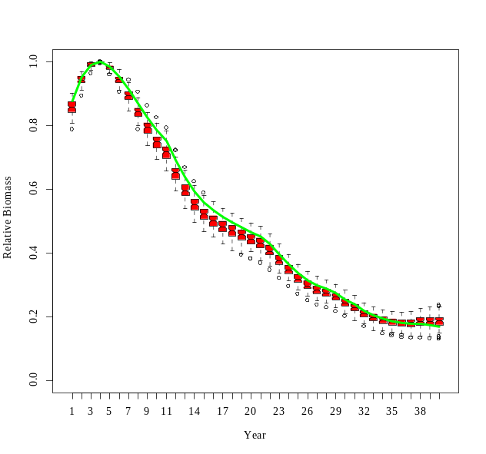

Model 4
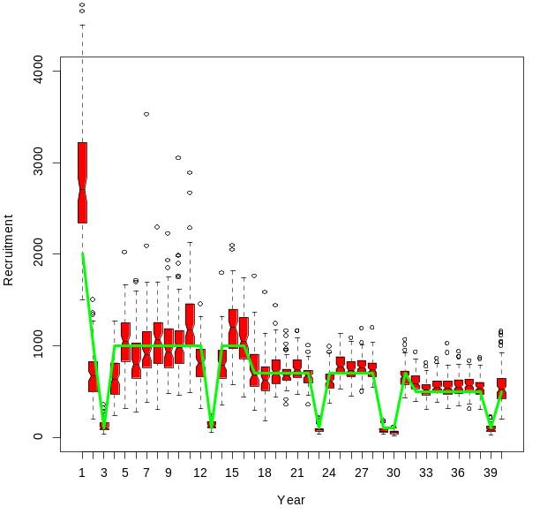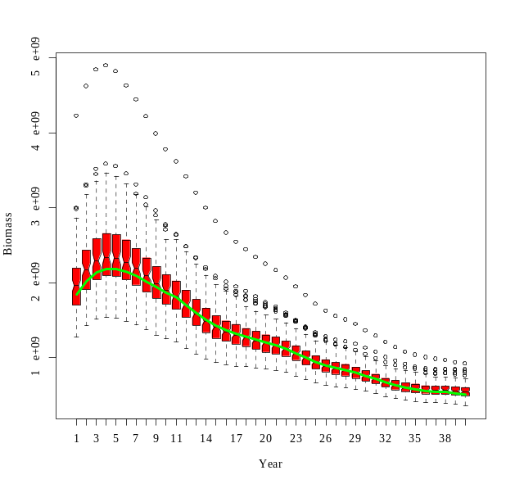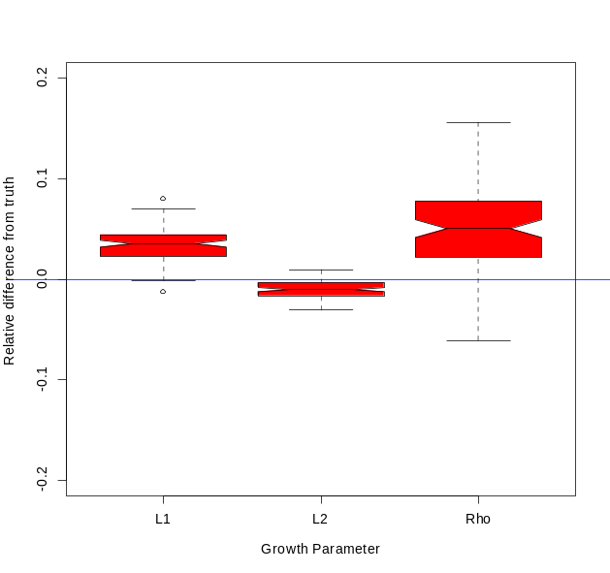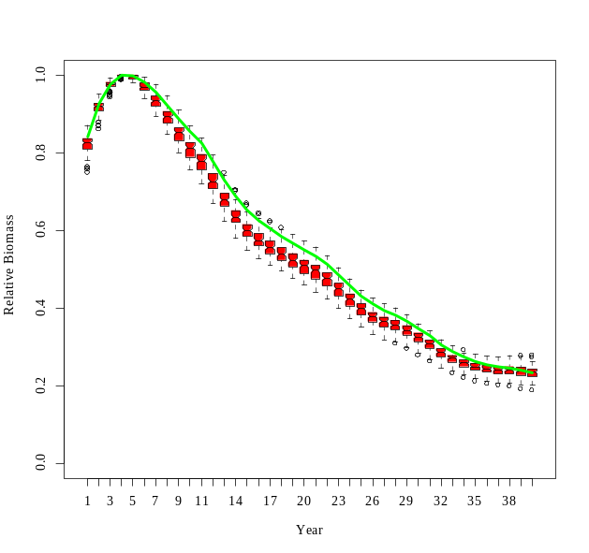

Model 6
